FINally
Software Design Document

Daniel Sisco
4-20-07

About FINally

Software Purpose
The purpose of the FINally tool is to allow a user or small group of users to easily track personal expenses over a period of time. It will provide an expense entry method, as well as various graphical and numeric presentations of expense information.

Software Scope
One of the challenges encountered during a previous attempt to write this tool was system data entry. The previous tool (called FinTool) used an Excel format spreadsheet, and called upon the user to hand enter expenses as they occurred. This proved to be problematic because the user needed to keep the database in specific order to keep the tool happy, and because opening Excel is a lot slower than opening a svelte custom app.

Consequently, the primary purpose of this tool is not to autonomously collect data, but to allow (or force) the user to enter data into a safe database location and operate on that data as instructed by the user. If the user doesn’t have the discipline to keep the database up to date, the tool will simply provide an incomplete record of expenses.

This tool was built to work with Microsoft Windows XP OS, although the GUI toolkit (wxPython) is known to work with Macintosh and Unix based systems as well. The tool requires the user to be running the latest version of Python and have wxPython installed until an .exe can be generated.

Software Components
The FINally program is a multilayered Python application utilizing many Python toolkits to complete it’s functionality. Figure 1-1, shown below, illustrates the different layers:

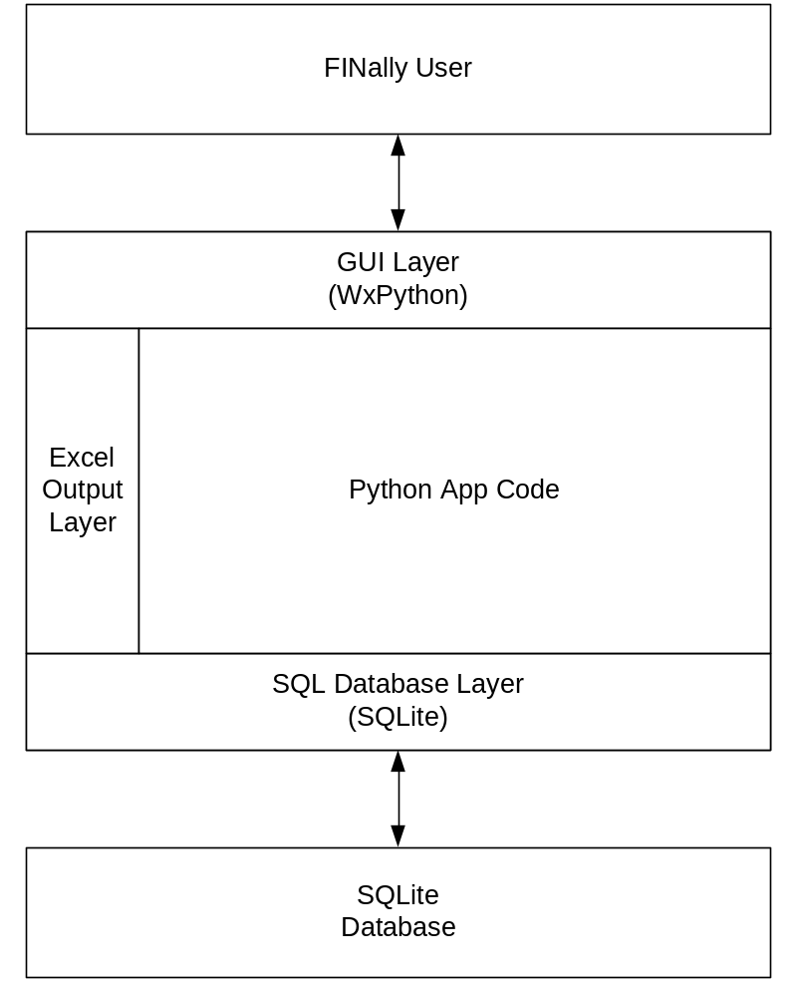
Figure 1-1: FINally software layers

Software Layers

SQL Database Layer
The SQL database layer is essentially a collection of SQLite drivers that connect the FINally application code and GUI layers to connect to the SQLite database. These drivers provide the following functionality: SQL database read, SQL database write, and SQL database search. These functions provide everything necessary for total functional access of the SQLite database.

The SQL database layer is also responsible for creating the appropriate tables upon FINally start. If the FINally application starts without a specific table defined and no default table exists, the SQL database layer will create an empty table and provide it to the application code.

GUI layer
This layer allows the user to interact with a set of GUI controls to enter and access FINally data. It provides the classes and functions for displaying all controls and windows, as well as monitors input events from the keyboard and mouse to determine when to trigger certain SQL Database Layer events.

This layer is the most complicated of the FINally layers, and really represents the majority of the FINally functionality. The Application layer exists to provide some glueware functions, but the GUI layer is the central nervous system of the application.

Application Layer

Excel Output layer

Feature List

SQL database features

SQL database/grid feedback
The SQL database must have access to the display grid so that changes on the grid can be pushed back to the SQL database. This will probably involve searching the database for a unique entry ID and modifying based on that.

I believe these IDs were stripped out of the grid because they are not typically shown to the user. They can either be shown to the user, or masked completely but not removed.

Additionally, a window should exist at the bottom of the tool so that if an ID cannot be found or something goes wrong – the user can see an error message of some sort.

GUI features

wxButtonPanel
I want to implement a wxButtonPanel style control scheme so that I can use gradient shading in my GUI design. I think this will help make the GUI a lot more customizable and user friendly and it shouldn’t add too much wxPython overhead.

Another idea for this section would be to add a color choosing panel to allow the user to change the appearance on the fly. This is shown in the ButtonPanel example in demo.py.

About Box
The tool should have an “About Box” that can be accessed to give version and creation information about the tool. It should also state what the default database name is, what the user name is, and other things of that nature.

wxSearchControl
The tool requires searchability over the database information and the search control wxPython object may be the easier and best looking way to achieve this. Options include providing a set of check boxes that dictate what we want to get back (ie: are we searching user, amount, date, desc, etc..).

The search line itself may be modified to allow certain syntax that mirrors the SQLite query syntax, but should also be able to handle very basic search requests like searching on the phrase “ExpressDude”.

Output features

System features

Seach Functionality
The tool should have search functionality that operates on the information in the database. This may be accomplished using the SearchCtrl wxPython object, or using a custom setup. This is described in more detail in section 3.2.3

Windows feature

Registry Access
I want to give the tool access to the Windows registry for the purpose of storing the user name, default database file name, and other user by user information. This isn’t so important for Rachel and I, but would likely be important for a group of other users.

